You are given the root of a binary tree with n nodes where each node in the tree has node.val coins. There are n coins in total throughout the whole tree.

In one move, we may choose two adjacent nodes and move one coin from one node to another. A move may be from parent to child, or from child to parent.

Return *the* ***minimum*** *number of moves required to make every node have* ***exactly*** *one coin*.

**Example 1:**

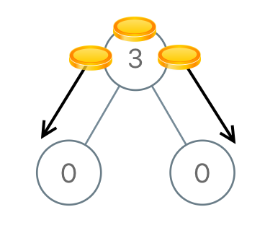

Input: root = [3,0,0]  
Output: 2  
Explanation: From the root of the tree, we move one coin to its left child, and one coin to its right child.

**Example 2:**

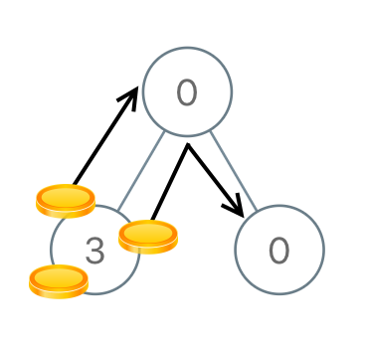

Input: root = [0,3,0]  
Output: 3  
Explanation: From the left child of the root, we move two coins to the root [taking two moves]. Then, we move one coin from the root of the tree to the right child.

**Constraints:**

* The number of nodes in the tree is n.
* 1 <= n <= 100
* 0 <= Node.val <= n
* The sum of all Node.val is n.